# **B.Sc. Engg. 1st Batch 4th Year 1st Semester 2019**

# **DBMS LAB**

**DISCUSSION-5**

**Java- SQL Server Connectivity**

# Creating an ODBC connection.

Step 1: Go to Control Panel -> System and Security->Administrative Tools-> Data source (ODBC)

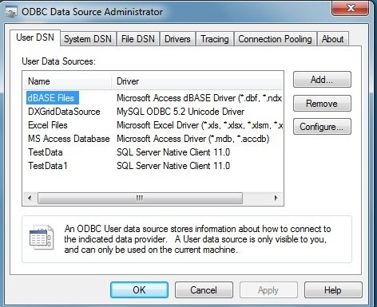

Step: 2 Click the Add button

Step 3: Choose the SQL Server click finish

Step 4: Choose a name for the Datasource, example: TestData and choose the SQL server from the server drop down list. (Mat take time)

Note: If the server name does not appear in the list, go to Services from the Administrative Tools and start the SQL browser service.

Step 5 Use Windows authentication

Step 6: Change the default database to pubs Step 7: Click next and then click finish

--------------------------

**Objective: To explore Java-SQL connectivity by showing/updating the Authors table of pubs database.**

import java.sql.*;

public class TestSQLJava

{

Connection con;

TestSQLJava()

{

createConnection();

//showData();

//showCustomData("172-32-1176");

//updateData("172-32-1176","CA");

}

void createConnection()

{

try

{ //Class.forName("sun.jdbc.odbc.JdbcOdbcDriver"); con=DriverManager.getConnection("jdbc:odbc:TestData"); }

catch(Exception exp) { System.out.print("No Connection with DB"+exp); }

}

void showData()

{

try

{

}

Statement st=con.createStatement();

ResultSet rs=st.executeQuery("Select * from Authors"); System.out.println("Author ID: \tAuthor last name: "); while(rs.next()) System.out.println(rs.getString(1)+"\t"+rs.getString(2));

catch(Exception exp) { System.out.print("Probleb with query result"+exp); }

}

void showCustomData(String au_id)

{

try

{

}

PreparedStatement pst=con.prepareStatement("Select * from Authors where au_id=?"); pst.setString(1,au_id);

ResultSet rs=pst.executeQuery(); System.out.println("Author ID: \tAuthor last name: "); while(rs.next()) System.out.println(rs.getString(1)+"\t"+rs.getString(2));

catch(Exception exp) {System.out.print("Probleb with query result"+exp); }

}

void updateData(String au_id, String state)

{

try

{

PreparedStatement pst=con.prepareStatement("update authors set state=? where au_id=?"); pst.setString(1,state);

pst.setString(2,au_id); pst.executeUpdate();

}

catch(Exception exp) { System.out.print("Probleb with query result"+exp); }

}

public static void main(String args[])

{

new TestSQLJava();

}

}